# SHOE MART

**By**

**PRAJWAL**

### Under Supervision Of

**Mr. Aravind R&D ENGINEER**

**EXPOSYS DATA LABS**

### To

**EXPOSYS DATA LABS**



### CERTIFICATE

**Candidate’s Declaration**

I hereby declare that the work presented in this report entitled “SHOE MART” in almost complete of the requirements for one month internship submitted to the Exposys Data Labs Limited is an authentic record of my own work carried out over a period from 11th February 2022 to 14th March 2022 under the supervision of Mr. Aravind, R&D Engineer, Exposys Data Labs.

The matter embodied in the report has not been submitted for the award of any other degree or diploma.

(Student Signature)

#### Prajwal

This is to certify that the above statement made by the candidate is true to the best of my knowledge.

(Supervisor Signature)

#### Mr. Aravind R&D Engineer

**Exposys Data Labs Date: 14 -03 -2022**

### **ACKNOWLEDGEMENT**

We would like to express our special thanks of gratitude to our supervisor Mr. ARAVIND R&D ENGINEER EXPOSYS DATA LABS who gave us the golden opportunity to do this wonderful project on Android Applications, which also helped us in doing a lot of research and we came to know about so many new things about android. We are really thankful to Exposys Data Labs for creating this wonderful opportunity to explore our potential in Software development.

Name of the Student

Date: 14-03-2022 Prajwal



|  |  |  |
| --- | --- | --- |
| **SI.NO** | **Table of Contents** |  |
| **1**  **1.1**  **1.2**  **1.3** | **Introduction** Problem Definition Objectives  Challenges |  |
| **2**  **2.1**  **2.2**  **2.3** | **Software Requirement Specification**  Functional Requirements  Non-Functional Requirements Hardware and Software Requirement |  |
| **3**  **3.1**  **3.2** | **System Design**  High Level Design Detailed Design |  |
| **4**  **4.1**  **4.2**  **4.3** | **System Implementation**  Module Description  Tools and Languages Used Screenshots |  |
| **5** | **Testing** |  |
| **6** | **Conclusions and Future Enhancements** |  |
| **7** | **References** |  |

**1. INTRODUCTION**

The "Shoe mart" has been developed to override the problems prevailing in the practicing manual system. This software is supported to eliminate and in some cases reduce the hardships faced by this existing system. Moreover this system is designed for the particular need of the company to carry out operations in a smooth and effective manner.

Shoe mart, as described above, can lead to error free, secure, reliable and fast management system. It can assist the user to concentrate on their other activities rather to concentrate on the record keeping. Thus it will help organization in better utilization of resources.

Every organization, whether big on ha engages to overcome and managing the information of Order, Customer, payment, shopping Cart, Payment. Every Online Shoes Store has different Customer needs, therefore we design exclusive employee management systems that are adapted to your managerial requirements. This is designed to assist in strategic planning, and will help you ensure that your organization is equipped with the right level of information and details for your future goals. Also, for those busy executive who are always on the go, our systems come with remote access features, which will allow you to manage your workforce anytime, at all times. These systems will ultimately allow you to better manage resources.

* 1. **Problem Definition:**

The aim of this project is to develop an website of Shoe Mart is to buy products online and save the timing. A shoe mart, who want to buy any product of their need, has to contact different Shoppers, before deciding upon a particular Product that best suit his needs, requirements and satisfaction. Moreover, most of the work involved in this development process has to be done manually which is very time consuming and cumbersome and also, it reduces the efficiency, accuracy.

To know the facts and understanding of the problem in detail, ***System Analysis*** is carried out. It is the process of studying the business processes and procedures, generally referred to as business systems, to see how they can operate and whether improvement is needed

* 1. **Objectives**
* The main objective of the Project on shoe mart is to manage the details of Customer, Order, Shoes, Payment.
* It manages all the information about Customer, Shopping Cart, Payment, Customer.
* The project is totally built at administrative end and thus only the administrator is guaranteed the access.
* The purpose of the project is to build an application program to reduce the manual work for managing the Customer, Order, Shopping Cart, Shoes.
* It tracks all the details about the Shoes, Payment.
  1. **Challenges**
* Customers consider online transactions or turnover and safety to be the second biggest challenge faced by ecommerce companies in India.
* Present days news about online fraud, tricky coupons, fake adds, spam e-mail and scam of credit card information being stolen has dynamic customer confidence in this system.
* As per present scenario, most of the customers in India prefer to buying stuff on (COD) cash on delivery basis.
* Due to lack of confidence security system, most of the customer using COD service [27].
* Developing Electronic Commerce solutions successfully across the Organization means building reliable, scalable systems for:

**2. SOFTWARE REQUIREMENT SPECIFICATION**

**2.1. Functional Requirements:**

* The system should have a list of shoe types.
* The system should supply user with list of shoes which fit better.
* For each shoe type there should be a picture describes it.
* The system should supply the user with a list of shops.

**2.2. Non-functional Requirements:**

**Performance Requirement**

The performance of the product mainly depends on the speed of Internet connection. If the user wants hard real time response, then this is definitely not the product to go for.

**Safety Requirements**

The electrical connection to the devices is critical and should be done according to the standards to avoid any short circuits.

**Security Requirements**

We aim to provide high security features like encryption to the user accounts to provide security from illegal hacking and gaining access to the system.

**2.3. Hardware and Software Requirements:**

**At Developer Side**

During system development, i have to design both static and dynamic website interfaces, create website functions and a database system, edit photos and pictures, so its has a set of software and hardware requirements.

|  |  |
| --- | --- |
| Hardware Used  * Intel i3 Core Processor * 500 GB Hard Disk Drive. * 4GB RAM. * O.S. – Windows 10 | Software Used  * WAMP SERVER * MYSQL Database * NOTEPAD * MS PAINT |

**At System Users Side**

The following is the requirements for the system users including members and administrators.

|  |  |
| --- | --- |
| Hardware Requirements   * Intel I3 Processor * 100 GB Hard Disk Drive. * 2 GB RAM. * O.S. – Windows 10 | Software Requirements   * Browser (Mozilla Firefox, Google Chrome * Browser Must be JavaScript Enabled |

**Front End Details**

Front End tool is used for give a Graphical user interface to system. By this we can make a system user friendly and more capable. I have chosen PHP as front end tool. Because it is an Open Source Technology, freely available and more familiar with any type of database.

**Back End Details**

Back end part of a system is more important because it controls all the internal process of a system. I have choose oracle database as back end. Because it is word’s Most Capable relational database and provide more security than others

**3.SYSTEM DESIGN**

The most creative and challenging phase of System Development Life Cycle (SDLC) is Software Design. SDS is systematic documentation of design. A design process involves “conceiving and planning out in the mind” and “making drawing pattern or sketch”. The term “design” describes a final system and the process by which it is developed. It assist in catching potential errors before the implementation phase itself which had been very costly to remove otherwise.

System Design is a solution how to translate the system requirement into a blue print for constructing the software. The goal of SDS is not only to produce a correct design but the best possible one within the limitation imposed by the requirements and the physical and social environment in which the system will operate.

**3.2. Detailed Design**

* **Search**

On this web site two type of user can search the book one is registered and another is unregistered. Registered user have to fill the form and then he/she can search or buy the Products but unregistered can only search the Products not buy the Product until they did not get the registered user.

* **Registration Form**

Shop will place registration form on the site. In this buyer interact with the shop. Buyer will get registration form from the site and fill those forms and submit on the site. Shop will store these registration forms in their database. In this we have to fill first name, last name, address, e-mail, etc.

**4. SYSTEM IMPLEMENTATION**

**4.1. Module:**

**Login Module** – This module is provided for administrator and users such as Product buyer and seller who have registered themselves in the system. These login are provided according to the need of the systems.

* + - **Input –** User id and password
    - **Process** – After entering user id and password by user process of validation occur to identify whether user id and password is available in database or not.
    - **Output** – Registered user can access website and can use the services.

**Administrator Module** – The administrator is provided with password and login-id with which he/she can access the system. Administrator is provided right of maintaining the database, verifies registered users.

* + - **Input** – Login id and password.
    - **Process** – Process of validation will occur.
    - **Output** – Administrator will maintain the database and will perform Product seller process.

**User Module –** As users are the main visitor of site, the following facilities are available through this module.

Can search the Products according to their need

Can order online book and pay via credit or atm card or PayPal.

Can get information about Products.

* + - **Input** – User Id and password
    - **Process** – Process of validation will occur.
    - **Output** – Only genuine user can access services provided by website.
    - **4.1. MODULE DECRIPTION**

**FLOWCHART**

**Shoe Mart**

Login / Index

*Authentication*n

*reply*

*Request*

Products / Cart / Shopping

*Operation/data processing*

*(Acknowledgement*)

*(Approved/Reject)*

Payment / Checkout

*(Acknowledgement)*

*Payment / Submission*

**(0 level DFD)**

**For Registration**

User

Details

Username Exists

Success

**For Login**

User Request

Access Denied

Not Authenticate

Authenticate

Buy Products

**For Buying Product:**

User Request

User’s Cart

Checkout

**E-R Diagram**

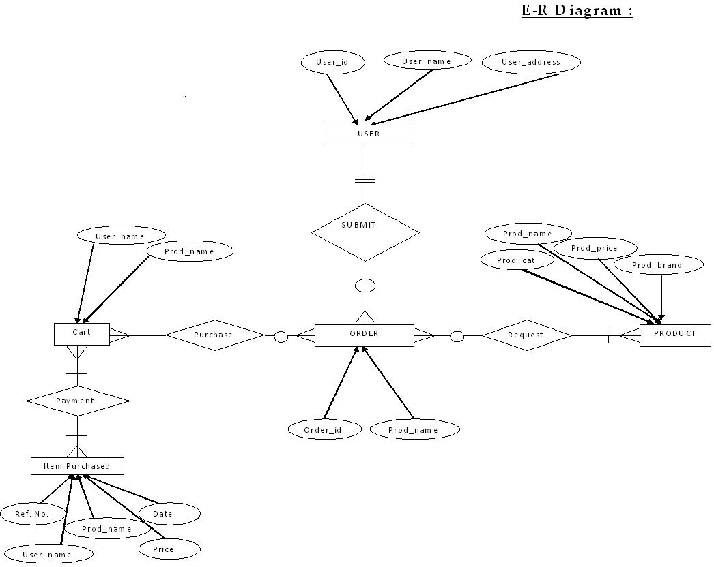

**4.2 Tools, Language and RDBMS used-**

**Language Used** PHP

**Database** MySQL

**User Interface Design** HTML, JAVASCRIPT

**Web Browser** Google Chrome

**Software** XAMPP

**Hardware** PC or Laptop

**4.3. SCREENSHOTS:**

**Home Page:**

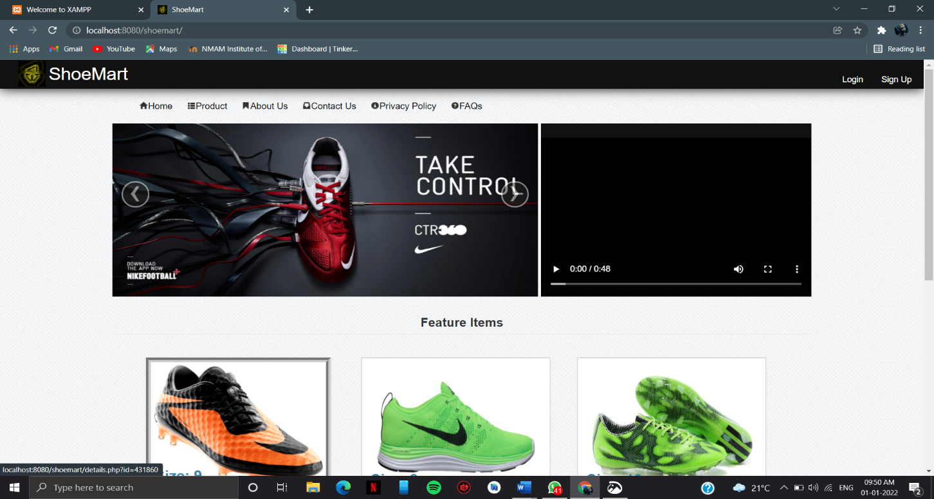

**Product Page:**

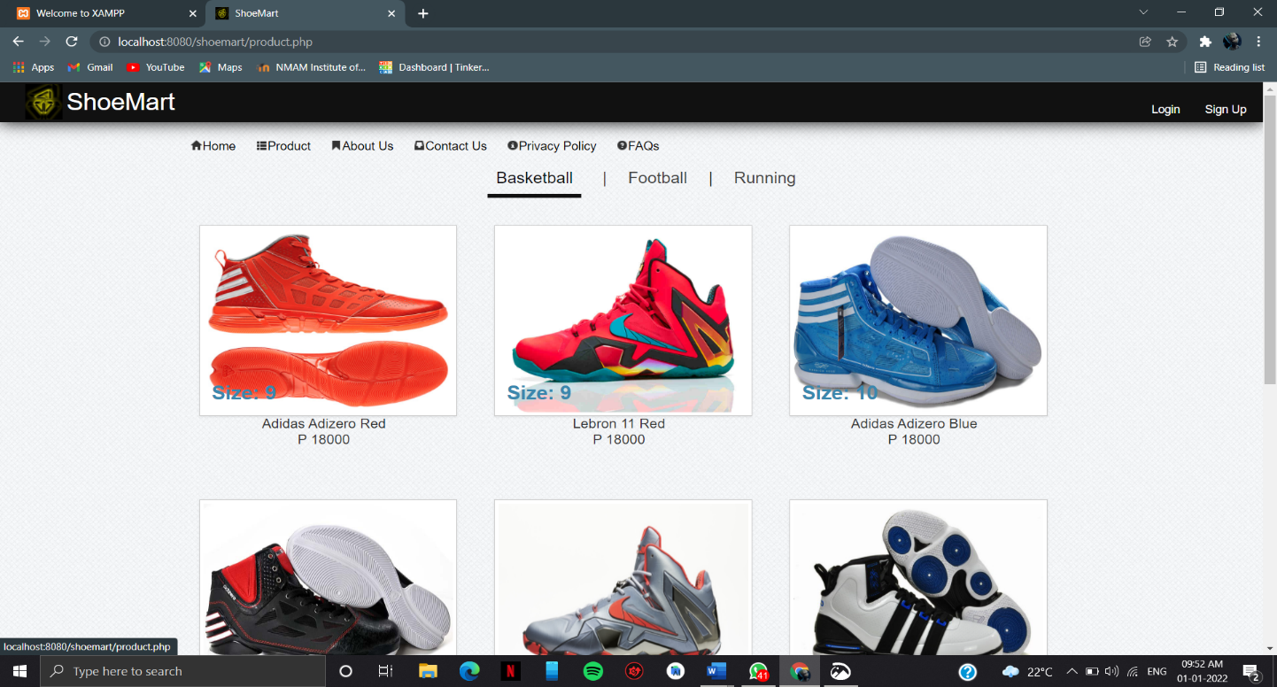

Sign Up Page:

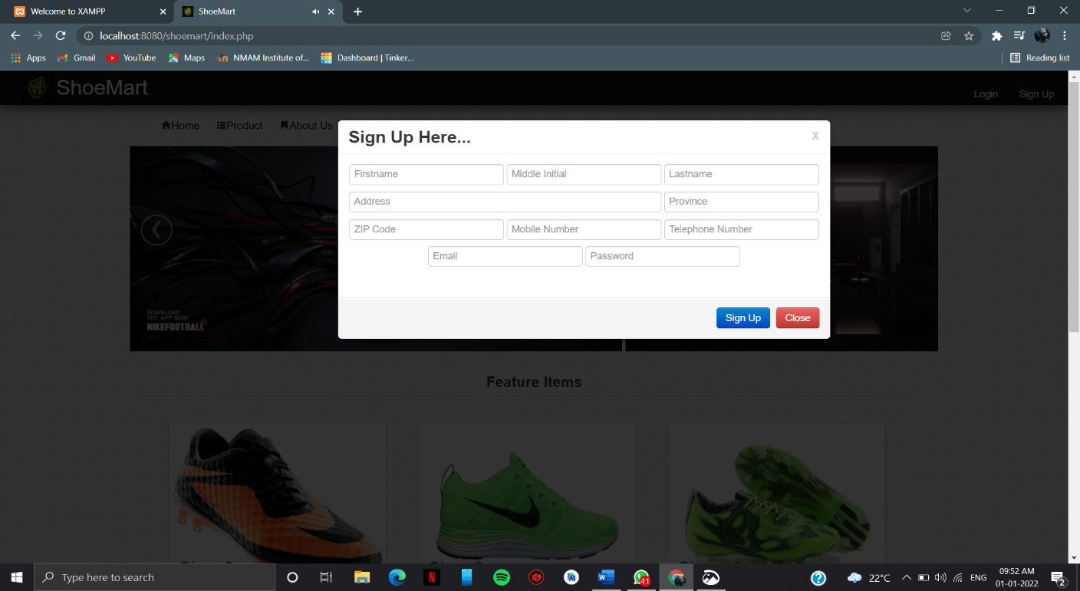

**Login Page:**

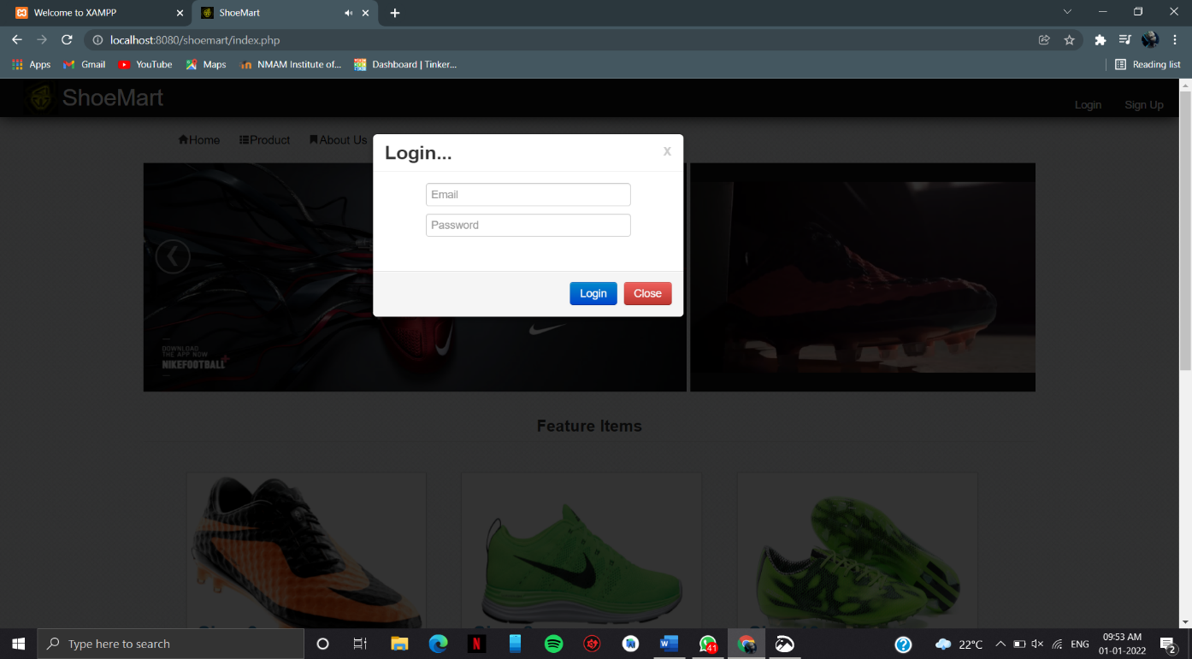

User Profile:

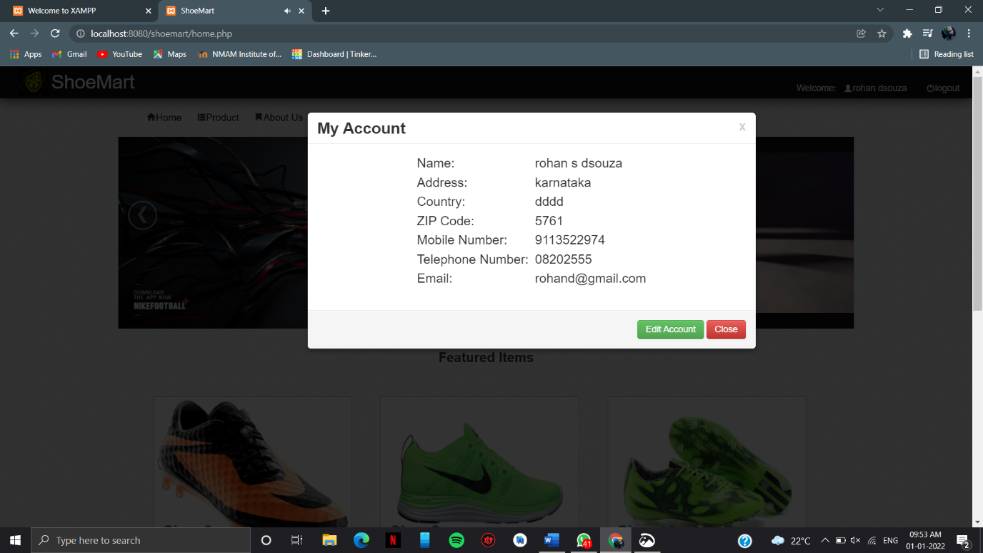

View Product:

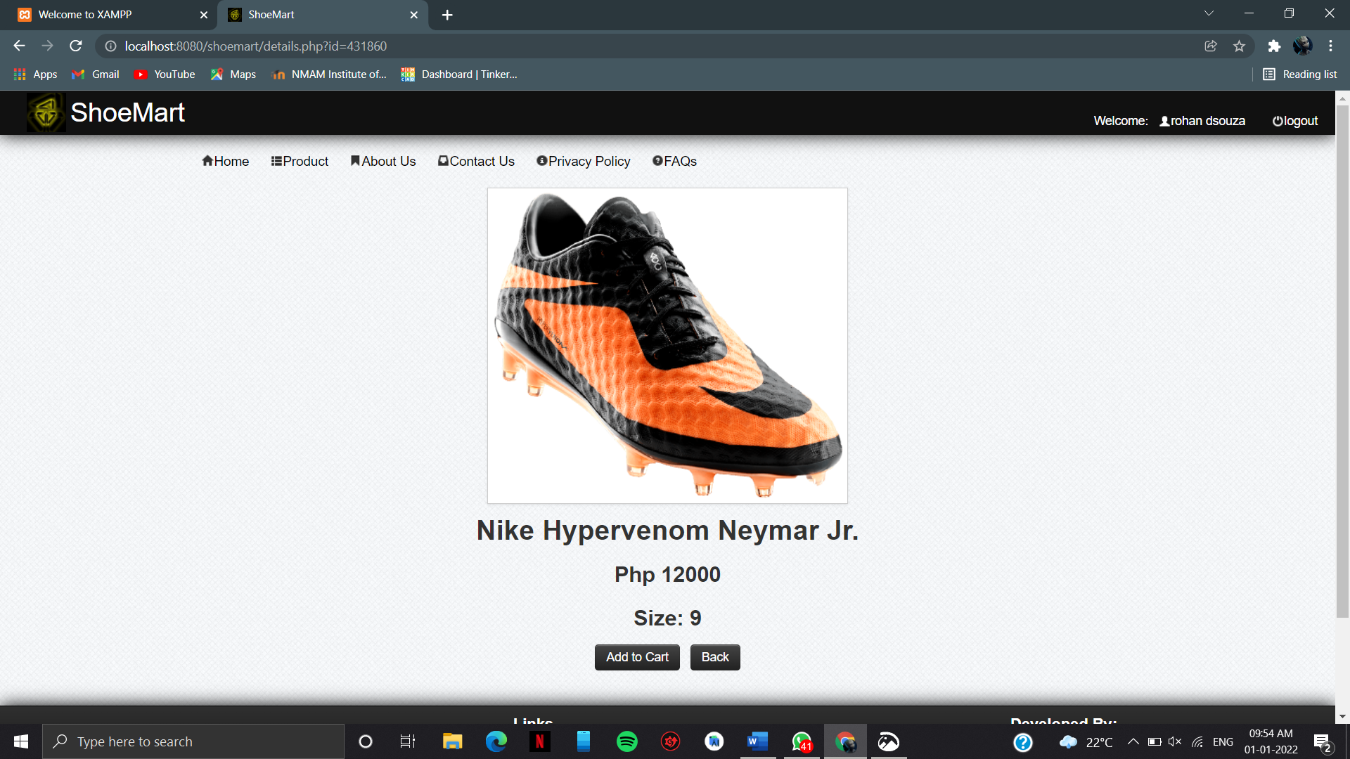

Add to cart Page:

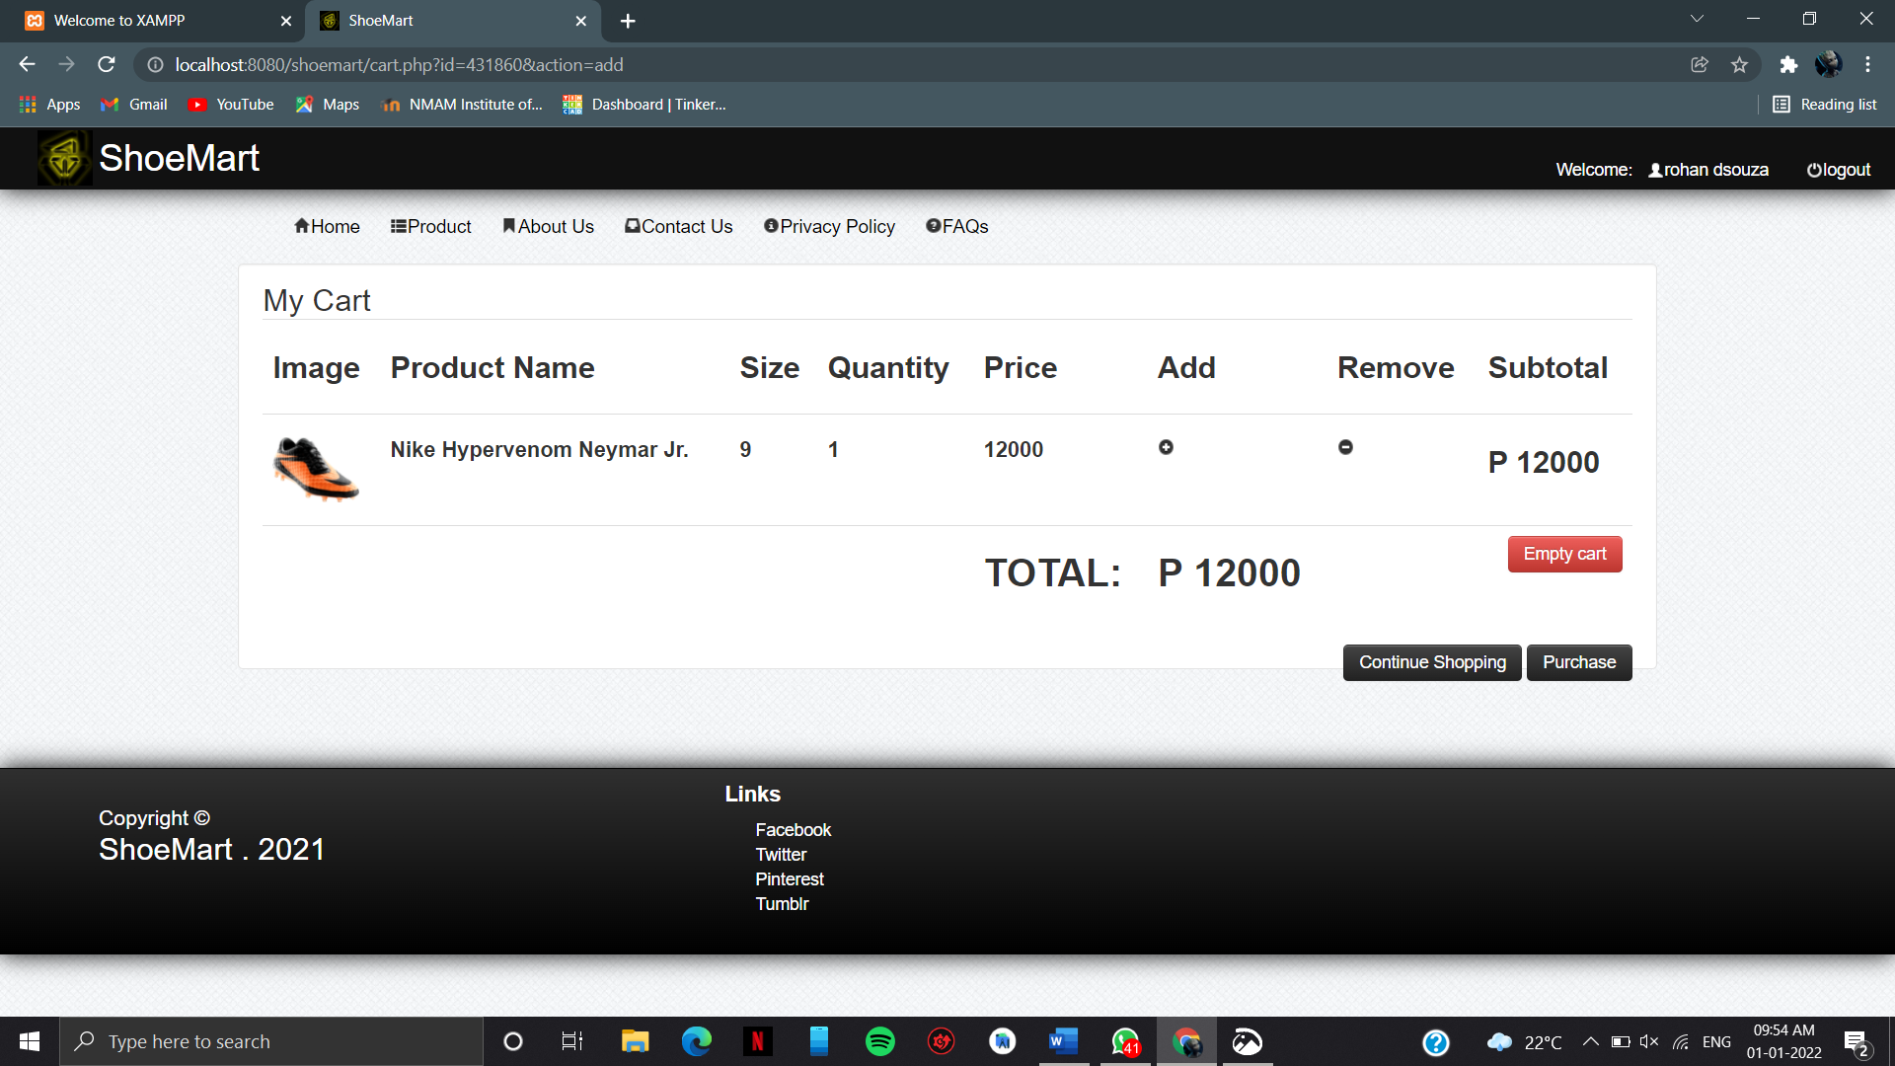

Buy Product:

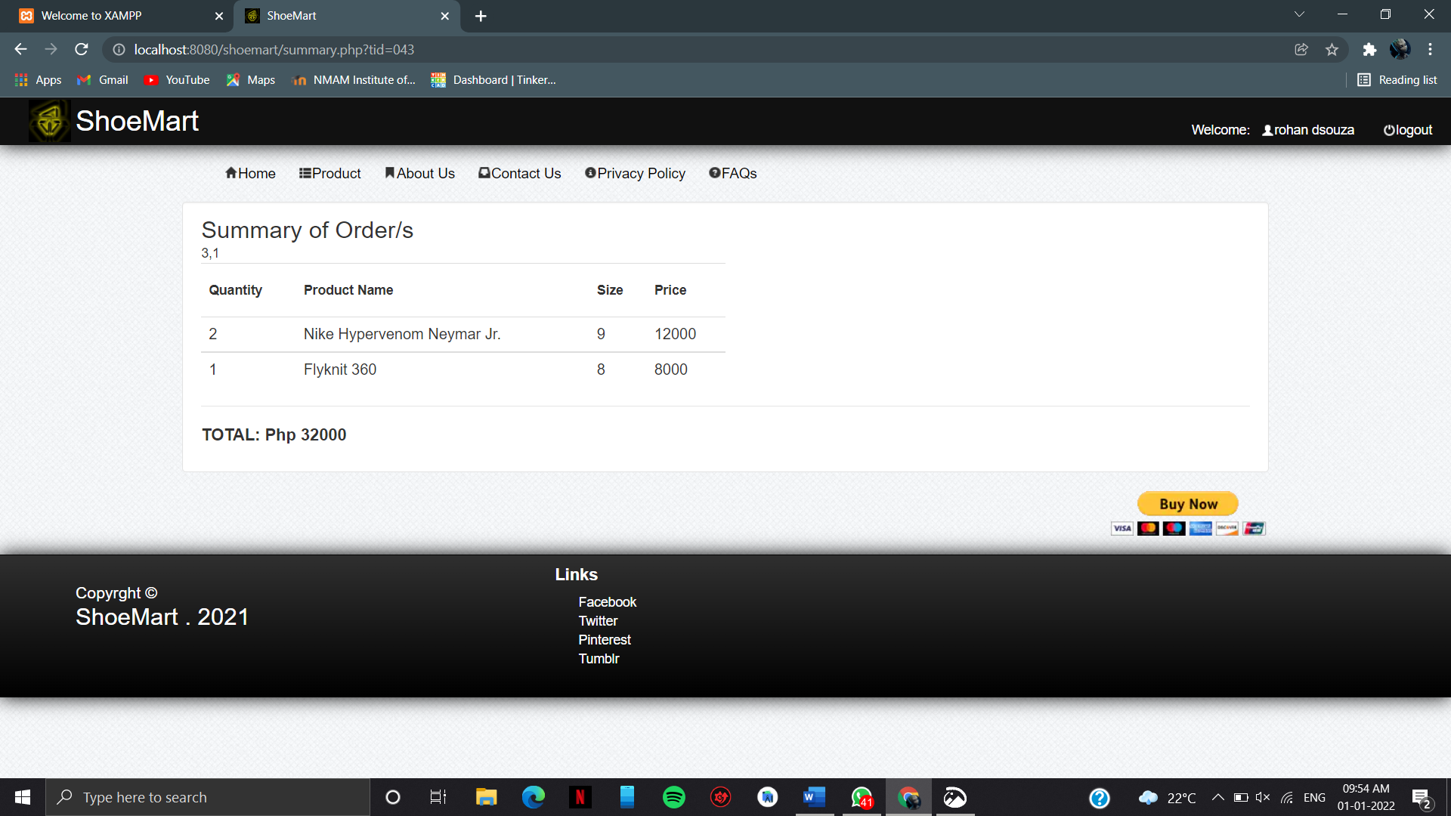

Admin Login Page:

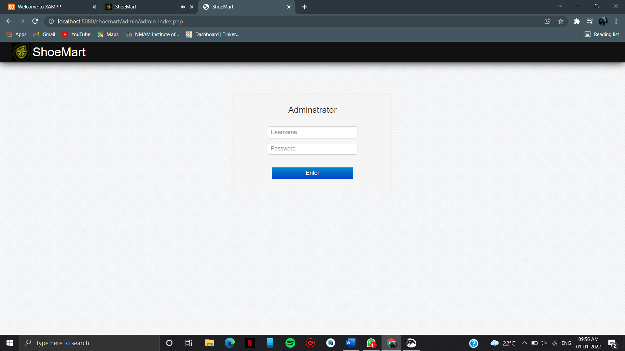

**Admin Dashboard:**

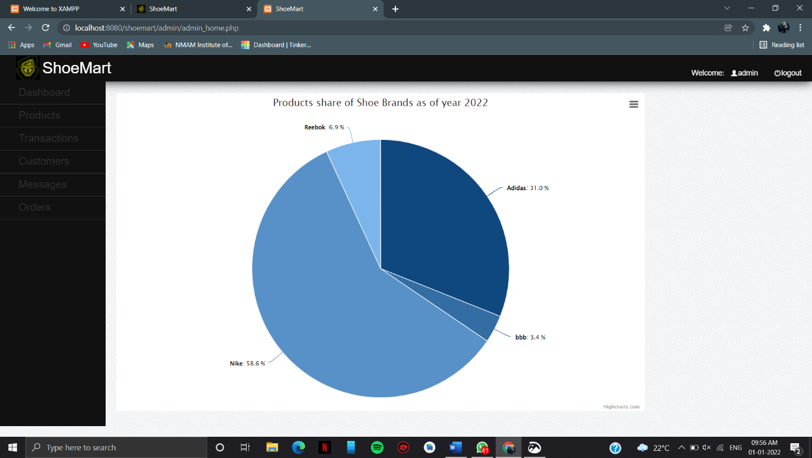

**Admin Add Product Page:**

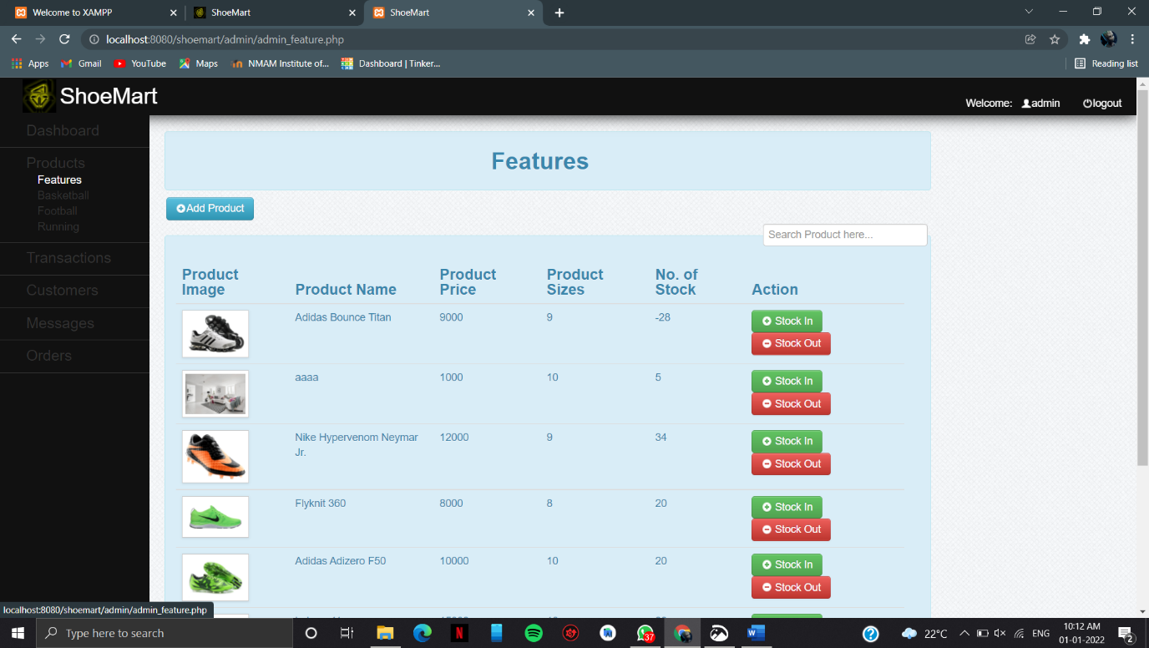

**Transaction Page:**

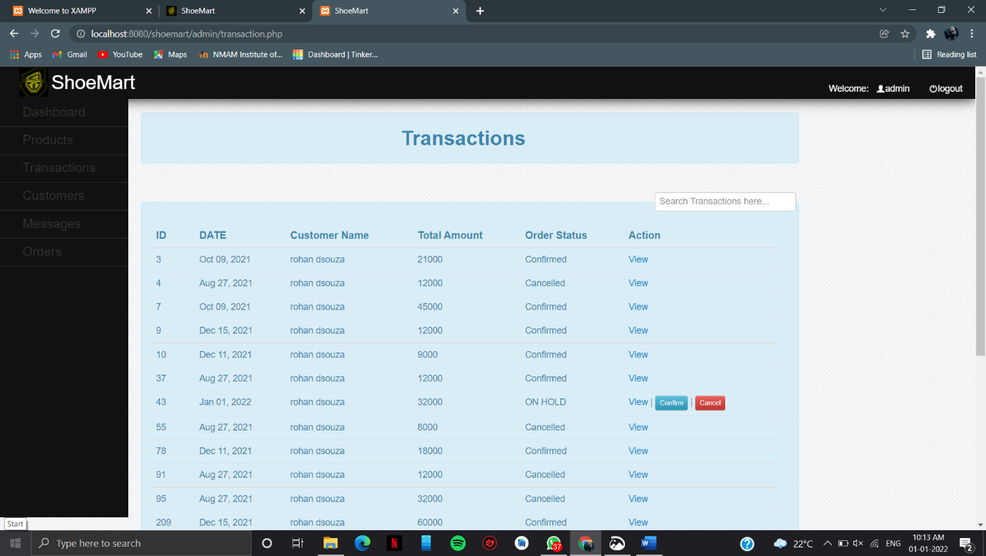

**5. Testing:**

**Login form:**

|  |  |  |  |  |
| --- | --- | --- | --- | --- |
| Sl.No | User Action | Expected Result | Observed Result | Test Result |
| 1 | If email is blank but password is entered. | Enter email_id | Same | Successful |
| 2 | If password is blank but email is entered. | Enter password | Same | Successful |
| 3 | If the email and password is valid. | System displays the home page | Same | Successful |

**User registration form:**

|  |  |  |  |  |
| --- | --- | --- | --- | --- |
| **Sl.No** | **User Action** | **Expected Result** | **Observed Result** | **Test Result** |
| 1 | When the user clicks”sign up” | It adds new record to database. | Same | Successful |
| 2 | If you enter numbers in name | Letters only | Same | Successful |
| 3 | If the password not valid | Please fill valid password.it should be strong including uppercase, lowercase, digit and special charater. | Same | Successful |
| 4 | If you not include @ in email | Include @ in email address | Same | Successful |
| 5 | If you enter phone number is more than 10 digits | Phone number 7-9 and remaining 9 digits with any number | Same | Successul |

**Change password**

|  |  |  |  |  |
| --- | --- | --- | --- | --- |
| **Sl.No** | **User Action** | **Expected Result** | **Observed Result** | **Test Result** |
| 1 | Mandatory fields left blank | Please fill the field | Same | Successful |
| 2 | Valid input | Password change successfully | Same | Successful |

**Other cases:**

|  |  |  |  |  |
| --- | --- | --- | --- | --- |
| **Sl.No** | **User Action** | **Expected Result** | **Observed Result** | **Test Result** |
| 1 | Click on logout | Application closes and redirects  to introduction page | Same | Successful |
| 2 | Click on submit with entering deails | Record is submitted to the database | Same | Successful |
| 3 | Click on submit without entering the details | Appropriate error message is displayed | Same | Successful |
| 4 | Click on drop down list | Selecting data is displayed | Same | Successful |

**6. Conclusion**

The project work entitled “ Shoe Mart” has been designed using JAVASCRIPT,CSS as front end and PHP, MYSQL as back end, were in many users friendly from have been added in order to make it a user interactive application. The system is developed in such a way that the user with basic knowledge of computer can work with it easily. The system has produced the report required by the customer and fulfilled all the objectives.

Therefore, it is important to have an online platform that can be managed by admins and accessed by customers (the application). Hence, these components are essential to ensure that the application can provide the best experience to the users. Simply put, the application can be used as a powerful module that can solve customer’s problems especially finding the right vehicle in online. Also, the application can help online sellers and showroom creators to promote their products to millions of customers by injecting various products into the application. Therefore, there can be so many possibilities of what the application are capable of achieving.

The future enhancement to the system can be made as technology changes.

**7. References**

* Keeves PHP- MYSQL
* Wrox Press – Beginning PHP5
* Online at [www.w3schools.org](http://www.w3schools.org)
* Murach’s-PHP/MYSQL